|  |
| --- |
| advance traffic controlling system (SMART CITY)  DLD PROJECT REPORT |
| Submitted To: MISS MARIA INCLUDES:   * 4 WAY TRAFFIC SIGNAL * SMART STREET LIGHT * INTELLIGENT PARKING SLOT |



## INTRODUCTION:

### **4 WAY TRAFFIC LIGHT SYSTEM**

Traffic lights, also known as traffic signals, traffic lamps, traffic semaphore, signal lights, stop lights, robots (in [South Africa](https://en.wikipedia.org/wiki/List_of_South_African_slang_words) and most of [Africa](https://en.wikipedia.org/wiki/Africa)), and traffic control signals (in technical parlance),[[1]](https://en.wikipedia.org/wiki/Traffic_light#cite_note-1) are signaling devices positioned at [road intersections](https://en.wikipedia.org/wiki/Intersection_(road)), [pedestrian crossings](https://en.wikipedia.org/wiki/Pedestrian_crossing), and other locations to control flows of traffic.

The world's first traffic light was short lived. It was a manually operated gas-lit signal installed in [London](https://en.wikipedia.org/wiki/London) in December 1868. It exploded less than a month after it was implemented, injuring[[2]](https://en.wikipedia.org/wiki/Traffic_light#cite_note-autogenerated2-2) its policeman operator. Traffic control started to seem necessary in the late 1890s and Earnest Serine from Chicago patented the first automated traffic control system in 1910. It used the words "STOP" and "PROCEED", although neither word lit up.[[3]](https://en.wikipedia.org/wiki/Traffic_light#cite_note-3)

Traffic lights alternate the [right of way](https://en.wikipedia.org/wiki/Right-of-way_(traffic)) accorded to users by displaying lights of a standard color (red, amber (yellow), and green) following a universal [color code](https://en.wikipedia.org/wiki/Colour_code). In the typical sequence of color phases:

The green light allows traffic to proceed in the direction denoted, if it is safe to do so and there is room on the other side of the intersection.

The amber (yellow) light warns that the signal is about to change to red. In a number of countries – among them the [United Kingdom](https://en.wikipedia.org/wiki/United_Kingdom) – a phase during which red and yellow are displayed together indicates that the signal is about to change to green.[[4]](https://en.wikipedia.org/wiki/Traffic_light#cite_note-4) Actions required by drivers on a yellow light vary, with some jurisdictions requiring drivers to stop if it is safe to do so, and others allowing drivers to go through the intersection if safe to do so.

A flashing amber indication is a warning signal. In the [United Kingdom](https://en.wikipedia.org/wiki/United_Kingdom), a flashing amber light is used only at [pelican crossings](https://en.wikipedia.org/wiki/Pelican_crossing), in place of the combined red–amber signal, and indicates that drivers may pass if no pedestrians are on the crossing.

The red signal prohibits any traffic from proceeding.

A flashing red indication is treated as a [stop sign](https://en.wikipedia.org/wiki/Stop_sign).

In some countries traffic signals will go into a flashing mode if the conflict monitor detects a problem, such as a fault that tries to display green lights to conflicting traffic. The signal may display flashing yellow to the main road and flashing red to the side road or flashing red in all directions. Flashing operation can also be used during times of day when traffic is light, such as late at night.

### **SMART LIGHT SYSTEM**

Intelligent street lighting refers to public [street lighting](https://en.wikipedia.org/wiki/Street_lighting) that adapts to movement by pedestrians, cyclists and cars. Intelligent street lighting, also referred to as adaptive street lighting, dims when no activity is detected, but brightens when movement is detected. This type of lighting is different from traditional, stationary [illumination](https://en.wikipedia.org/wiki/Illumination_(lighting)), or dimmable street lighting that dims at pre-determined times.

Street lights can be made intelligent by placing [cameras](https://en.wikipedia.org/wiki/Camera) or other [sensors](https://en.wikipedia.org/wiki/Sensors) on them, which enables them to detect movement (e.g. Sensity’s Light Sensory Network, GE's "Currents").[[4]](https://en.wikipedia.org/wiki/Intelligent_street_lighting#cite_note-4) Additional technology enables the street lights to communicate with one another. Different companies have different variations to this technology. When a passer-by is detected by a camera or sensor, it will communicate this to neighboring street lights, which will brighten so that people are always surrounded by a safe circle of light.[[5]](https://en.wikipedia.org/wiki/Intelligent_street_lighting#cite_note-5) The Smart Lighting technology of the Anhalt University of Applied Sciences does this as well, and has been installed in Bernburg-Strenzfeld in Germany.[[6]](https://en.wikipedia.org/wiki/Intelligent_street_lighting#cite_note-6) Street lights illuminate at a longer distance ahead of the pedestrian than behind the pedestrian in the Smart Lighting concept.

Control

Some companies also offer software with which the street lights can be monitored and managed wirelessly. Clients, or other companies, can access the software from a computer, or even a tablet. From this software, they can gather data, pre-set levels of brightness and dimming time; receive warning signals when a light defects.

* **INTELLIGENT PARKING SYSTEM**

A parking lot ([American English](https://en.wikipedia.org/wiki/American_English)) or car park ([British English](https://en.wikipedia.org/wiki/British_English)), also known as a car lot, is a cleared area that is intended for [parking](https://en.wikipedia.org/wiki/Parking) vehicles. Usually, the term refers to a dedicated area that has been provided with a durable or semi-durable surface. In most countries where [cars](https://en.wikipedia.org/wiki/Automobile) are the dominant mode of [transportation](https://en.wikipedia.org/wiki/Transportation), parking lots are a feature of every city and suburban area. [Shopping malls](https://en.wikipedia.org/wiki/Shopping_mall), sports [stadiums](https://en.wikipedia.org/wiki/Stadium), [megachurches](https://en.wikipedia.org/wiki/Megachurch) and similar venues often feature parking lots of immense area.

Parking lots tend to be sources of [water pollution](https://en.wikipedia.org/wiki/Water_pollution) because of their extensive [impervious surfaces](https://en.wikipedia.org/wiki/Impervious_surfaces). Most existing lots have limited or no facilities to control runoff. Many areas today also require minimum [landscaping](https://en.wikipedia.org/wiki/Landscaping) in parking lots to provide shade and help mitigate the extent of which their paved surfaces contribute to heat islands. Many [municipalities](https://en.wikipedia.org/wiki/Municipality) require a minimum number of parking spaces, depending on the floor area in a store or the number of bedrooms in an apartment complex. In the United States, each state's [Department of Transportation](https://en.wikipedia.org/wiki/Department_of_Transportation) sets the proper ratio for disabled spaces for private business and public parking lots. Various forms of technology are used to charge motorists for the use of a parking lot. Modern parking lots use a variety of technologies to help motorists find unoccupied parking spaces, retrieve their vehicles, and improve their experience.

* **COMPONENTS LIST:**

1. 555 Timer IC
2. Johnson Counter 4017 IC
3. 3 Input AND Gate
4. NOT Inverter IC
5. Traffic Light Colour LEDS
6. White LEDS
7. LDRS
8. Capacitors
9. Connecting Wires
10. DC Source 15Volts

* **ABOUT THE IC’S**

1. **555 TIMING IC:**
2. The [555 timer](https://electronicsforu.com/videos-slideshows/diy-ne555-timer-circuit) IC is an integral part of electronics projects. Be it a simple project involving a single 8 bit micro-controller and some peripherals or a complex one involving system on chips (SoCs), 555 timer working is involved. These provide time delays, as an oscillator and as a flip-flop element among other applications.
3. Introduced in 1971 by the American company Signetics, the 555 is still in widespread use due to its low price, ease of use and stability. It is made by many companies in the original bipolar and low-power CMOS types. According to an estimate, a billion units were manufactured back in the year 2003 alone. (That time, only 555 I knew was a cough syrup).
4. Depending on the manufacturer, the standard 555 package includes 25 transistors, 2 diodes and 15 resistors on a silicon chip installed in an 8-pin mini dual-in-line package (DIP-8). Variants consists of combining multiple chips on one board. However 555 is still the most popular. Let’s look at the pin diagram to have an idea about the timer IC before we talk about 555 timer working.
5. 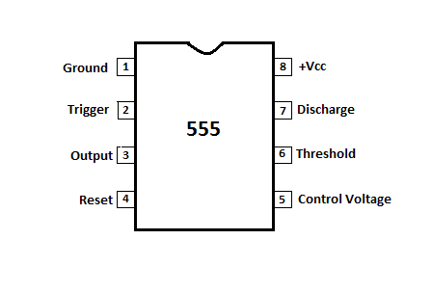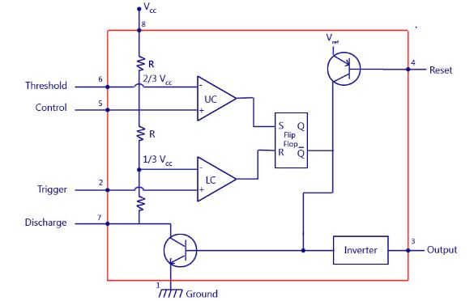

**JOHNSON DECADE COUNTER**

**An Introduction to IC4017**

Most of us are more comfortable with 1, 2, 3, 4… rather than 001, 010, 011, 100. We mean to say that we will need a decimal coded output in many cases rather than a raw binary output. We have many counter ICs available but most of them produce binary data as an output. We will again need to process that output by using decoders or any other circuitry to make it usable for our application in most of the cases.

Let us now introduce you a new IC named IC 4017. It is a CMOS decade counter cum decoder circuit which can work out of the box for most of our low range counting applications. It can count from zero to ten and its outputs are decoded. This saves a lot of board space and time required to build our circuits when our application demands using a counter followed by a decoder IC. This IC also simplifies the design and makes debugging easy.

[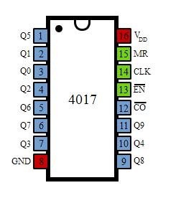](https://www.elprocus.com/wp-content/uploads/2013/05/IC-4017-Pin-Diagram.jpg)IC 4017 Pin Diagram

It has 16 pins and the functionality of each pin is explained as follows:

* Pin-1: It is the output 5. It goes high when the counter reads 5 counts.
* Pin-2: It is the output 1. It goes high when the counter reads 0 counts.
* Pin-3: It is the output 0. It goes high when the counter reads 0 counts.
* Pin-4: It is the output 2. It goes high when the counter reads 2 counts.
* Pin-5: It is the output 6. It goes high when the counter reads 6 counts.
* Pin-6: It is the output 7. It goes high when the counter reads 7 counts.
* Pin-7: It is the output 3. It goes high when the counter reads 3 counts.
* Pin-8: It is the Ground pin which should be connected to a LOW voltage (0V).
* Pin-9: It is the output 8. It goes high when the counter reads 8 counts.
* Pin-10: It is the output 4. It goes high when the counter reads 4 counts.
* Pin-11: It is the output 9. It goes high when the counter reads 9 counts.
* Pin-12: This is divided by 10 output which is used to cascade the IC with another counter so as to enable counting greater than the range supported by a single IC 4017. By cascading with another 4017 IC, we can count up to 20 numbers. We can increase and increase the range of counting by cascading it with more and more IC 4017s. Each additional cascaded IC will increase the counting range by 10. However, it is not advisable to cascade more than 3 ICs as it may reduce the reliability of the count due to the occurrence glitches. If you need a counting range more than twenty or thirty, I advise you to go with conventional procedure of using a binary counter followed by a corresponding decoder.
* Pin-13: This pin is the disable pin. In normal mode of operation, this is connected to ground or logic LOW voltage. If this pin is connected to logic HIGH voltage, then the circuit will stop receiving pulses and so it will not advance the count irrespective of number of pulses received from the clock.
* Pin-14: This pin is the clock input. This is the pin from where we need to give the input pulses to the IC in order to advance the count. The count advances on the rising edge of the clock.
* Pin-15: This is the reset pin which should be kept LOW for normal operation. If you need to reset the IC, then you can connect this pin to HIGH voltage.
* Pin-16: This is the power supply (Vcc) pin. This should be given a HIGH voltage of 3V to 15V for the IC to function.

This IC is very useful and also user friendly. To use the IC, just connect it according the specifications described above in the pin configuration and give the pulses you need to count to the pin-14 of the IC. Then you can collect the outputs at the output pins. When the count is zero, Pin-3 is HIGH. When the count is 1, Pin-2 is HIGH and so on as described above.

* clock
* **3-INPUT AND GATE**

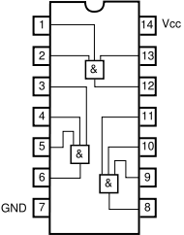The **AND gate** is a basic digital [logic gate](https://en.wikipedia.org/wiki/Logic_gate) that implements [logical conjunction](https://en.wikipedia.org/wiki/Logical_conjunction) - it behaves according to the [truth table](https://en.wikipedia.org/wiki/Truth_table) to the right. A HIGH output (1) results only if all the inputs to the AND gate are HIGH (1). If none or not all inputs to the AND gate is HIGH, a LOW output results. The function can be extended to any number of inputs.

* NOT GATE:

Inverter circuit outputs a voltage representing the opposite logic-level to its input. Its main function is to invert the input signal applied. If the applied input is low then the output becomes high and vice versa. Inverters can be constructed using a single [**NMOS**](https://en.wikipedia.org/wiki/NMOS_logic) transistor or a single [**PMOS**](https://en.wikipedia.org/wiki/PMOS_logic) transistor coupled with a [resistor](https://en.wikipedia.org/wiki/Resistor). Since this 'resistive-drain' approach uses only a single type of transistor, it can be fabricated at low cost. However, because current flows through the resistor in one of the two states, the resistive-drain configuration is disadvantaged for power consumption and processing speed. Alternatively, inverters can be constructed using two complementary transistors in a [**CMOS**](https://en.wikipedia.org/wiki/CMOS) configuration. This configuration greatly reduces power consumption since one of the transistors is always off in both logic states. Processing speed can also be improved due to the relatively low resistance compared to the **NMOS**-only or **PMOS**-only type devices. Inverters can also be constructed with [bipolar junction transistors](https://en.wikipedia.org/wiki/Bipolar_junction_transistor) (**BJT**) in either a [resistor–transistor logic](https://en.wikipedia.org/wiki/Resistor%E2%80%93transistor_logic)(**RTL**) or a [transistor–transistor logic](https://en.wikipedia.org/wiki/Transistor%E2%80%93transistor_logic) (**TTL**) configuration.

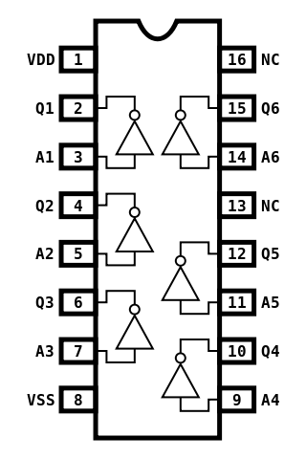

**METHODOLOGY/WORKING:**

1. 4 WAY TRAFFIC SIGNAL**:**

Four-way **traffic light circuit diagram using 555 Timer IC** is shown in the above diagram. The timer here generates pulses of time period 100ms approximately. So, the **ON** time is **50ms** and **OFF** time is **50ms**. This time duration can be changed by changing the capacitor value. Although street lights have a shift time for **2minutes**, here we are reducing the time for testing the circuit.

The time shift for a**four-way traffic light**can be achieved in this circuit by replacing the **10uF** capacitor with a **470uF** one. Once the power is tune **ON**, the timer acts as a square wave generator and generates clock, this clock is fed to the **DECADE BINARY** **COUNTER.** Now the decade binary counter counts the number of pulses given at the clock and lets the corresponding pin output go high, for example, if the event count is 3 then **Q2** pin of counter will be high and if **5** is count the pin **Q4** will be high. So, for every **100ms** there will be a peak, with this peak the counter memory gains by one and so is the output.

The diodes here prevent the shorting of counter outputs, say if the count is two with this the **Q1** will be high (**since Q1 is high all other outputs will be low including Q0, Q2**) in the absence of diodes, **Q1** with positive voltage gets hardly pulled down to **LOW** by **Q0** (as **Q0** voltage be **+0V** when **Q1** is **high**), as they are connected together. With this short circuit takes place.

So, during **Q0, Q1, Q2, Q3** high the **GREEN LED** on **NORTH** and **SOUTH** will be **ON** along with **RED LED** on **EAST** and **WEST**. So, if we assume clock is of **1Hz,** the **NORTH** and **SOUTH** side are signaled **GREEN** to go for four sec and also the **EAST** and **WEST** side are signaled **RED** to **STOP** during this time.

When **Q4** goes high, the **YELLOW LED** on **NORTH** and **SOUTH** will be **ON** along with **RED LED** on **EAST** and **WEST**. So, if we assume clock is of **1Hz**, the **NORTH** and **SOUTH** side are signaled **YELLOW** to slow down for **1sec** and also the **EAST** and **WEST** side are signaled **RED** to **STOP** during this time.

When **Q5, Q6, Q7, Q7** high the **GREEN LED** on **EAST** and **WEST** will be **ON** along with **RED LED** on **NORTH** and **SOUTH**. So, if we assume clock is of **1Hz**, the **EAST** and **WEST** side are signaled **GREEN** to go for four sec and also the **NORTH** and **SOUTH** side are signaled **RED** to **STOP** during this time.

When **Q4** goes high, the **YELLOW LED** on **EAST** and **WEST** will be **ON** along with **RED LED** on **NORTH** and **SOUTH.** So, if we assume clock is of **1Hz,** the **EAST** and **WEST** side are signaled **YELLOW** to slow down for **1sec** and also the **NORTH** and **SOUTH** side are signaled **RED** to **STOP** during this time.

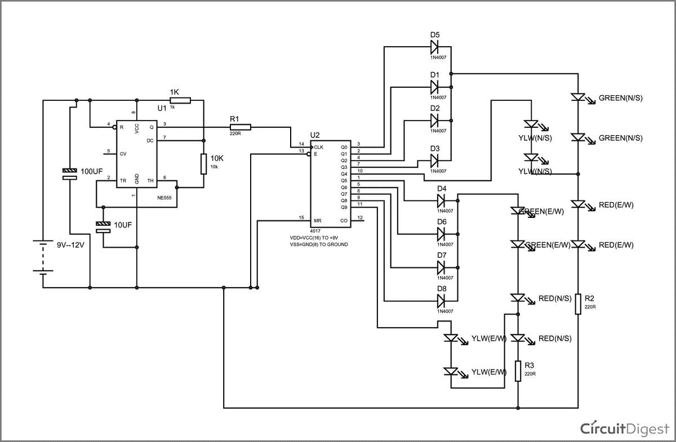**4 WAY TRAFFIC SIGNAL CIRCUIT DIAGRAM**

1. INTELLIGENT PARKING SYSTEM:

The parking system works with a three input and gate **IC** and an inverter **IC**. In this **LDRS** are connected to all the three inputs of and gate and at output a red **LED** is connected and from output of and gate the input of **NOT** gate is given and at output of **INVERTER IC** the **GREEN LED** is connected. As all the three slots are full then **RED LED** lights up or any one slot is left empty the green led lights up.

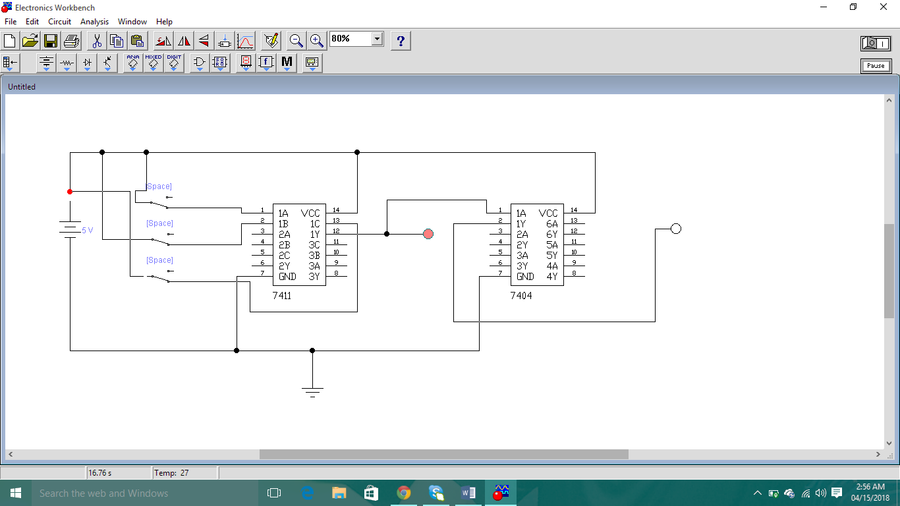

1. SMART STREET LIGHT SYSTEM:

In today's world, more amount of electricity is consumed due to street lights. This is due to continuous operation of lighting during the night time. In order to reduce the electricity consumption and wastage of energy, the system that has to combine the existing network with intelligence to think itself. This newly developed concept will enable the street lights to adjust automatically based on the real time traffic conditions and change according to naturalistic condition (Full moon). This paper is concerned with the development and implementation of Low Cost Sensor based Street Lights with dynamic which in turn reduces the energy consumption and CO2 emission. It consists of IR sensor, PIR sensors, low cost embedded controller and storage device.

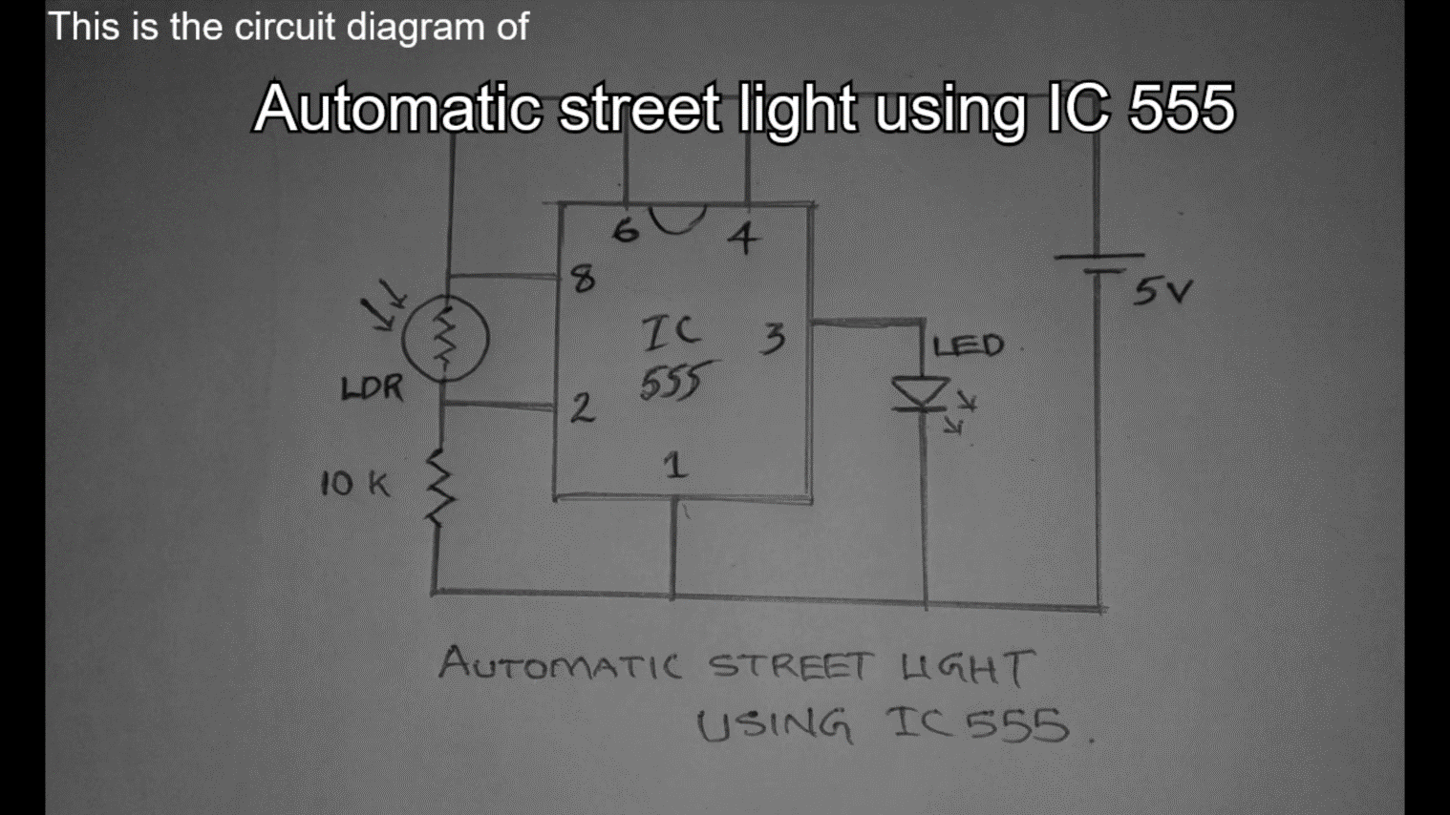

## CONCLUSION:

## Through this practical ICs we can save the power consumption which is use by street lights and with the counter it can widely be used in which we have to show combinations Asynchronous way & by making Intelligent parking slot we can give a view to the consumer that the slot where he’s going to park is empty or occupied!